HACKING AND PPE
What is the  Hazard | Who might be harmed and how | Preventative steps already in place  Further preventative steps. | Action Date  Risk
Prior  to  Hacking |  | Read all the NPRC documentation on hacking , lead rein hacks before taking any form of hack.  Know routes and what level and length each route is  Read the clients rider registration form; look closely at the medical history and the rider’s ability for hacking.  Only take the level of hack and route that ties up with the boxes ticked for the section on the riders registration form.  Get as much previous history of the clients previous hacking experience  Before any hack is taken out an assessment lesson must be given in the school ( this does not apply to long standing clients who’s ability is known to the center)  Try to see all clients on the horse they are going to hack out ridden by them before they hack.  Before any beach hacks read the notes and guidance on booking in beach hacks and rules for escorting a beach hack.  Any medical worries speak to a manager, get a doctors letter from the client and also get conformation from your insurance company.  Always inform the yard of the route you are going to take.  When beach hacking you need to work out the tide times and the length of the hack and allow enough time to get home before it gets dark.  Assess weather conditions before leaving for the hack. The weather can change very quickly now days especially in the winter months if it’s very windy then change the hack for another day.
Hacking | ST, SU, LC, RC  Falls  Accident with cars | When riding out you should have as much of your arms covered, minimum a polo shirt in Summer  Jodhpurs at all times  Gloves should be worn at all times when riding  Hat to current BSI standard/European PAS015,ASTM F 1163, SNELL 2001– must fit correctly. New hats are advised every five years or following a fall.  Children under the age of 14 MUST wear a helmet which complies with BS Standards. It MUST be fastened securely.  Hairnet for long hair, or tied up satisfactorily.  Long boots or Jodhpur boots & short chaps. Lightly ridged soled boots are allowed, but boots with heavily ridged soles are not permitted.  Hi viz tabards should be worn every time hacking in both Summer and Winter.  In winter or days that are darker then the horse should also wear PPE  Most accidents occur just as dawn is breaking and at dusk when the roads are not that well lit from natural light and horse and riders with no PPE cannot be seen that well.  The member of staff should carry a mobile phone in a specially designed armband case; never attach the phone to the horse.  Take the small portable first aid kit with you.  Have a spare lead rope attached to the escorts horses saddle  If the hack exceeds more than 6 riders then a rear escort must be taken.  With 4 or more riders on a beach hack a second escort must be taken, unless they are liveries riding their own horses.  See guidelines for What to do when leading a client | On going  Med/High
Tack | ST, SU, LC, RC  Falls  Loose of control | All tack is checked weekly and is in the tack check log book  Tack is checked by the member of staff escorting the hack before leaving to include checking the girth.  Check the rider is comfortable and the sturips are of suitable length to hack | On going  Low
Route | ST, SU, LC, RC  Falls  Trips | We have pre described route for various levels of rider and abilities.  All riders start with the lower level of hack prior to moving up to advanced hacks | On going  Low/Med
Shoeing | ST, SU, LC, RC  Slips  Falls | All horses are on a regular shoeing list, but ensure all shoes are well secure and safe prior to a long hack, beach hack
EXTRA INFO
The BHS recommends that all riders wear fluorescent/reflective clothing at all times when riding out, regardless of the time of day, time of year or prevailing weather conditions.
It’s a good idea to ensure that both you and your horse are wearing hi-viz in case you have a fall and your horse runs off without you – he’ll stand a far better chance of reaching home safely if passersby and motorists can see him.
“Wearing hi-viz when riding on the road can give vehicle drivers a valuable three seconds extra ‘reaction time’ that could save the life of both you and your horse! To put it into context those three seconds are equivalent to a car, driven at 30 mph, travelling the length of a full size dressage arena.
Research has shown that helicopter pilots can see a rider in hi-viz gear up to half-a-mile sooner and thus avoid flying straight over the top of them. It also means that in the unfortunate event that a rider is thrown from their horse and left in open countryside, the police helicopter or air ambulance will see them much sooner and prevent their injuries from becoming more serious.
Many hi-viz garments now reach BSI approved standards – which shows they have been tested to approved levels for use. These standards are BSEN1150 or EN1150 which is aimed at use by leisure rider
Remember that there are more than 4.2 million riders in Britain and 26 million licensed vehicles on the roads. Every day there are more than 8 horse related traffic accidents
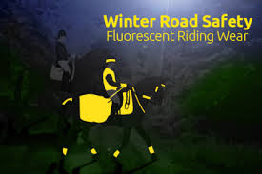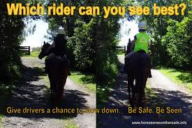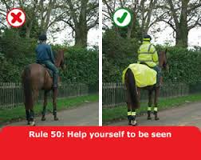

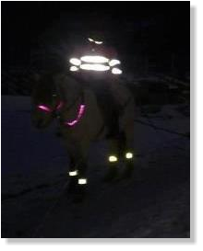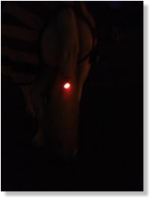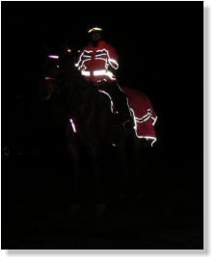
SOME DO AND DON’T’S FOR RIDING THROUGH THE SEASONS
Spring
Spring is a lovely time of year, but if you have a new horse or one that you have not ridden in Spring you may get a bit of a shock. The Spring grass coming through gives horses a little sugar boost and some horses may be a bit more fresh. Aside from a fresh horse, there are other dangers in spring. Horses, like humans, can get hay-fever and other allergies such as sweet itch making them extremely uncomfortable. An uncomfortable horse will be even more unpredictable than usual and surely very grumpy. This will obviously make them more dangerous on the road, as a driver will not know that your horse has an ailment, they will just assume your horse is out of control. Always consult a vet if you have issues with your horse.
Signs of pollen allergies or sweet-itch
•Constant rubbing of the tail/mane
•Head shaking or tossing
•Kicking out with the hind legs
•Tail swishing
•Trying to scratch on anything in reach
•Rolling (even with you on!)
•Sneezing
•Coughing
•Snot
Another issue in spring can be on public bridleways and in fields with livestock. Spring is the time for birthing and many animals especially cattle are very protective of their young.
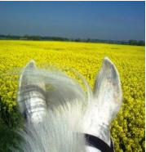 Spring 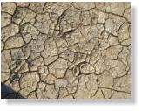 Summer 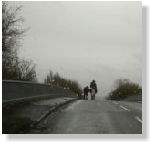Autumn 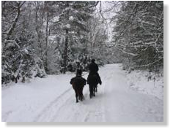 Winter

Summer
Summer comes with many of the same issues as spring but there it is more likely to be hotter and dryer (if you’re lucky!). If you plan a long hack be sure to take a water bottle attached to the saddle or in a back pack and also don’t forget sun block. Be sure to put some on your horse if they have white areas e.g. ears or noses. The ground may also be very hard and riding on it may jar or hurt your horse’s legs so excessive galloping over a bridleway may be out of the question. Roads may also become slippery in extremely hot weather, making them almost as slippery as ice especially if your horse is shod. If you feel the road may be slippery try to stay to the sides where there is likely to be more debris which can help your horse to stop from slipping too much. Car tires can also be effected by this, so ensure drivers can see you and ask them to slow down when approaching you. If the weather is extremely hot many riders are tempted to ride with just light clothing but hi-viz is still essential for the roads.

Autumn
Autumn brings with it the change of colour on the trees, the leafy monsters that chase our horses, rain and the loss of the summer nights. When the rain starts it make the fields turn into bogs and the roads can easily flood. But it also decreases visibility. The photo shows how dull a horse and rider can look in the rain and against a hedge they could be even less visible. If you must ride in the rain, ensure you wear fluorescent and reflective clothing.
Mud
Riding in fields and on bridleways becomes practically impossible when the ground is saturated. However if it is essential then being safe about it is key. Mud is obviously slippy so studs in a horses shoes will help to stop them sliding. Letting them find their own balance by dropping the reins will help if your horse does begin to slip. Do not force your horse to go any faster than a walk in very deep mud as they could pull a muscle or trip over.
Floods
If you are caught out in the rain or have had a lot of rain and a road you need to pass becomes flooded you must check it before you ride through it to ensure it is safe for your horse.
•Wrap your mobile in plastic for example a sandwich bag. Should your horse trip, become injured or spook and you come off, it is very handy to have a dry phone!
Winter
Winter Along with the wet and the dark, the winter usually brings the cold. Ice and sometimes snow can halt the whole country, but horses still need to be cared for. Riding in these conditions brings with it probably the greatest of risks as drivers are less in control of their cars especially if they do not expect to see a horse on the road.
Ice
If you need to hack your horse in winter, the following tips will help you be better prepared on the roads if there is frost:
Only hack out in the ice if you cannot stay at home it’s better to exercise in the sand school and wait for the weather to clear.
•If you have shoes on your horse, look into getting road studs. They will give grip on the ice.
•Should your horse slip a lot, it would be safer to get off. Your horse will be able to balance better and you are less likely to get hurt by him falling.
•Making sure you are seen with hi-viz can affect the speed drivers go, thus the speed they slow at. On ice all cars have the potential to slide if they are going fast enough and not slowing down gradually.
Snow
Snow can be beautiful and fun to ride in but it comes with the same dangers as ice but with the added danger of not being able to see the road or where the ice is. If the world is white.
•Visibility is extremely poor in snow, it is best to avoid roads altogether if it is snowing or about to snow. If the snow has fallen and the sky is blue, a short road hack is possible.
• Again, never walk over a gateway you don’t know as there may be a hidden cattle grid.
•The world is black and white in the snow as the picture below shows, but the sun reflective off the snow can hide yellow too. If you are riding out on a road, the best colour to wear is orange.
•If you have a bridle path, make sure you know it like the back of your hand and preferably have used it within the past few days so that any changes or damage could be noted. Also ride only in fields you know, and on hilly/higher ground. Low ground may have puddles that have turned to ice which have then been covered in snow.
•Snow balling in the hoof will cause the horse to become unbalanced and be unable to walk correctly, as if they were on stilts. To avoid snowballs forming in your horses hooves you can ride in either boots or using specific snow pads which a farrier can put on. If you have neither of these then the best prevention is to use Vaseline in copious amounts on the hoof and underneath. Avoid putting it on the shoes or very edges of the hoof where it may interfere with walking.
Darkness Unless you have a lit arena or have time in the day to ride, riding or leading in the dark can be unavoidable. The biggest issue is of course people not being able to see you until they are extremely close. Horses are prey animals and the most dangerous time for them (if they were in the wild) is night time. Horses generally have good eyesight in the dark but this can also be a disadvantage as something that we cannot even see may be terrifying to your horse. The following tips will help to increase your safety if you need to ride in the dark
•Reflective wear is a must when riding or leading in the dark. You should wear at least vest and hat strip on yourself and your horse should have at least a tail guard and martingale and band on their legs.
•Flashing lights are a good way of being seen before the car is close enough to see your reflectivity. You can get specific rider vests with flashing lights, tail guards and halters/nosebands too. Remember that red must go to the back and white to the front to signal to drivers which way you are facing. If possible you should carry an extra light to put on your hand so you may be seen when signaling to turn

