PLEASE REMEMBER TO ENSURE ALL TACK IS CHECKED AND SAFE PRIOR TO THE RIDER MOUNTING
THE RIDER HAS COMPLETED A RIDER REGISTRATION FORM RECENTLY
THE RIDER IS CORRECTLY DRESSED, HAT, BACK PROTECTOR, GLOVES AND RIDING BOOTS
Name | DETAILS |  | INFORMATION | RISK  LEVEL
Cross Country Course | A selection of cross country jumps to cater for complete beginners to advanced riders, in paddocks covering approx 8 to 10 acres, jump sizes range from 30cm to 1mtr, jumps are of solid fixed wood structure.  The smaller 30cm fences are portable and need to be fixed.  The course is fully enclosed by post and rail fencing.  PLEASE ENSURE THAT THE GATES ARE CLOSED WHEN USING THE COURSE.  All under 16yrs must be accompanied by an adult when on the course.  All lessons must be taken by a senior member of staff fully competent with xc riding.  No loose dogs on the course.  All spectators must watch from the gate or sit on the table fence that is not used on the course for lessons.  When taking a lesson or clinic a First aider must be present, this will normal be the instructor as well.  A first aid kit for both horses and humans must be taken with you.  If possible have an extra member of staff to help especially when having less experienced clients on the lessons.  Have a mobile phone or radio with you on the course. |  | If the ground is hard sand or shavings should be applied before and after any jump to prevent concussion to the hooves, if snowy or icy DO NOT USE  After heavy rain the paddock will be slippery the horses should have studs in their shoes. If they don’t have studs then the lesson/ clinic should be postponed.  The paddock will have wild animals such as rabbits / hares and birds roosting in the trees that could fly out as the horses pass ALWAYS ensure that the course is walked before and the rider(s) are aware of any hazards that could cause the horses to spook.  Check for rabbit holes  All horses should have been tried and tested by staff prior to any clients using them for Cross Country. If they haven’t DO NOT USE, if you are unsure seek guidance from the management  Small portable cross country fences should be ground anchored unless used with wings and a pole over the top, they are used more like fillers.  All large portable cross country fences must be ground anchored with large fixing screws, jumps up to can be fixed using a solid steak permanently fixed into the ground | MEDIUM
PLEASE REMEMBER TO ENSURE ALL TACK IS CHECKED AND SAFE PRIOR TO THE RIDER MOUNTING
THE RIDER HAS COMPLETED A RIDER REGISTRATION FORM RECENTLY
THE RIDER IS CORRECTLY DRESSED, HAT, BACK PROTECTOR, GLOVES AND RIDING BOOTS
Name | DETAILS | INFORMATION |  | RISK  LEVEL
Cross Country Fences | There are a range of fences from 30cm to 1m. The fences range in variety, and permanently fixed and portable fences.  The 30cm XC jumps are better used in the smaller show jump paddock and ideally for younger riders and nervous. The paddock is also smaller so the horse can’t get so fast and gallop | All fixed fence must be checked for stability and any signs of rot or deterioration of the fence.  See the XC risk assessment and jump log.  Any nails protruding  All strapping checked for security  Any concerns must be raised immediately with management and that jump taken out of use.
Cross Country Field | The cross country course is in three of the turnout fields and covers approx10 acres. These fields are also used for turnout and grazing.  Prior to any XC taking place the fields must be walked and all fences fully checked prior to use | The field in certain places can become worn or poached through the winter so will need to be rolled before use  The fields adjoin the farmer’s land which has rabbits in it and these will start to dig at the turn out paddocks so the filed needs monthly checks for any signs of the start of rabbit holes.  Check all boundary fences just in-case there is a loose horse on the course.  Pick up all rubbish and stones that may have risen to the surface.
Cross Country Clothing | When riding xc it is a high risk sport and all safety measures should be in place.  All tack should be checked for suitability and safety  All horse clothing boots bandages should be checked suitability and safety  All rider clothes should be checked for suitability and safety and comply with current BE guidelines.  If it is a Pony Club event then all rider clothing should comply with PC guidelines | HATS SHOULD BE TO PAS 015/ SNELL 2001  LEVEL, BACK PROTECTORS SHOULD BE purple LEVEL 3(2009) AND MUST ALWAYS WORN  Air Jackets  A lanyard attached to the jacket is clipped onto a lead fixed to the horse's saddle. Once the rider leaves the saddle during a fall, the lanyard detaches itself from the air jacket triggering the release of CO2 gas from a canister.  The air jacket will hold a rider tight for 15-20 seconds and then slowly deflate.  When an air jacket inflates the sudden noise startles horse in the immediate area so by causing problems of others riders if air jackets are worn in groups.  The air jacket has been proved to work in three ways; to distribute pressure, absorb shock and support the spinal column in the event of a fall. When inflated, the airbag system offers the collar of the neck and trunk more support, thus reducing the risk of over bending the spinal column  Should it be worn with or without a body protector?  The safest way to wear the ProAir is in conjunction with a conventional body protector, however some riders choose to wear the air vest alone while hacking or riding at home.  Pony Club rules stipulate that when an air vest is used, it must be worn on top of a conventional body protector for all xc events. Other affiliated competition — for example British Eventing horse trials — stipulate that a BETA-approved Level 3 body protector must be used. The air jacket is fully reusable, and requires servicing annually or after every six falls.  After any fall XC your hat should be preplaced with a new one as although the shell out side can look ok it most probably has been compromised inside.

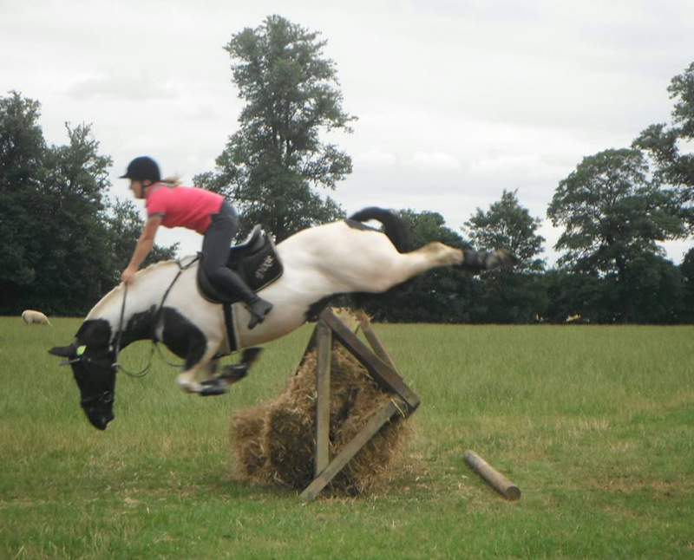

Cross Country Horse Jumps
Cross country fences can vary from natural jumps such as a fallen tree trunk or hedge to examples such as a hay cart or water trough. Cross country jumps are solid in design and do not fall down unless they are fitted with a special collapsing pin. What will make a cross country fence more challenging is the height and width of the fence along with where it is sited and how many jumps there are in any one combination along with considerations such as ground conditions, the type of fence that it is and whether it is being jumped from light into dark off a turn, into space or on the side of a hill.
Corner This is a triangle in design and the horse is asked to jump the corner of it. This type of fence requires practice in order to hold the horse straight over it and prevent the horse from running out. The width of the corner will vary and the wider it is the more experienced you will need to be in holding your line. This fence becomes more of a challenge when two or three corners are to be jumped quite often on a curve for an added challenge.
Novice - A long fence with a small angle allows the rider to jump slightly more centrally and reduces the amount of accuracy required. Advanced - Narrow fences with wide angles that require precision jumping to prevent the horse from running out. Two or three corners on a wiggly bend will need the concentration of both horse and rider... more about Corner Fences
Tree Trunk This inviting jump which horses seem to enjoy jumping is also known as a log fence. The height and width of the log fence along with the angle it is to be jumped at will add to the level of proficiency required.
Novice - Single log on the ground Novice - Single hanging log Advanced - 2 to 3 Logs to be jumped on an angle, and/or a narrow log requiring accuracy... more about Tree Trunk Fences
Angled Fence This is a post and rail fence which has to be jumped at an angle as opposed to straight on. The angle of the fence, the number of angle fences to be jumped and the number of strides in between each fence will determine the level of difficulty.
Novice - A single angled rail. Novice - Two angled rails with a one or two stride distance in between. Advanced - The angle to be jumped is more acute and the addition of two or three angled rails in a combination adds to the challenge... more about Angled Fences
Bounce This is where you have two fences, one closely followed by the other with a bounce distance in between each; this means that as soon as the horse lands it must immediately take off again. Safety now suggests that making the second fence look different helps the horse to realize that it must take off immediately on landing, therefore helping to prevent rotational falls.
Novice - Small bounce. Advanced - Bounce into water
Gate A fixed wooden gate that is to be jumped over, the height and positioning will again determine the technical rating.
Novice - Moderate in height in a well-lit area. Advanced - Jumping the gate on an angle. Advanced - Jumping the gate into or out of a wood (jumping from light into dark is always a challenge). Advanced - A gate within a combination of fences... more about Gate Fences
Wall A solid wall fence with a wooden top. The height, angle and position that it is to be jumped from will increase its difficulty rating.
Novice - Moderate in size on flat ground. Advanced - Jumping a corner of a wall. Advanced - Jumping the wall on an angle. Advanced - jumping a combination of wall fences.
Coffin This comprises of three elements a jump to start off with followed by a ditch and then another jump to finish. The height, width and depth of all three parts combined with the angle to be jumped at will determine the technicality of the fence.
Novice - Fences not too wide and ditch not too scary. Advanced - Fences up to height and the ditch deep and wide. Advanced - Coffin fences to be jumped on an angle.
Water This can be a natural stream or a manmade complex. The horse will be asked to splash through or jump in or out and/or jump a fence while in the water.
Novice - Splash through. Novice - Splash through followed by a jump out or on land. Advanced - Jumps into and out of water as well as over fences positioned within the water itself... more about Water Jumps
Palisade This is a fence on a slight 45 degree angle, which leans into the direction you are jumping it. This fence can easily be made more technical by the addition of a ditch in front, so that both the ditch and palisade have to be jumped in one go.
Novice - Palisade on its own. Advanced - Jumping a palisade with the addition of a very large ditch in front. Jumping a palisade which has been positioned at the top of a steep slope or in front of water both of which require a bold leap of faith... more about Palisade Jumps
Parallel This is a wide fence which has two separate poles marking out the length and width to be jumped, depending on the height of the parallel there are two or three further poles added to fill in the spaces between the ground and top pole.
Novice - Not too wide on good ground. Advanced - Placing the parallel over an open ditch or stream. Advanced - Having to jump a parallel on an angle. Advanced - Jumping a parallel as part of a combination of fences.
Steps These can be jumped going uphill or downhill. The height of the steps and the distance between each step will determine the difficulty, along with any other fences which may have been added either before and/or after the steps.
Novice - one or two steps reasonably small in height with one to two strides in between. Advanced - A series of steps at maximum height with a bounce distance in between and a separate single fence (often a style fence) added before and /or after.
Brush Fence These are made of thick brush and often have thinner brush left sticking up for the horse to jump through.
Novice - A small brush fence on the flat. Advanced - A brush fence into water. Advanced - A double of brush fences on an angle.
Tyre fence A group of tyres are linked together to form a jump. The height of the tyres, the position, type and number of fences will determine the difficulty of the fence.
Novice - A single fence of tyres. Advanced - Row of angled tyre fences. Advanced - Style fence made up of tyres.
Roll Top This type of fence is often made of wood and has a gentle upward curve, making it very inviting to jump, where it is positioned and where in relation to other fences it is sited will determine the technicality of the fence.
Novice - Single roll top. Advanced - Bounce of roll top styles. Advanced - Roll top into water.
Table Quite literally a flat top on four legs with the width, height and depth varying depending on the level it is designed for.
Novice - Moderate in height and width. Advanced - The bigger the better.
Trakehner This is a jump such as a log or rail placed over a ditch, the log or rail can either go straight across or at an angle and can both vary in size depending on the class of competition.
Novice - Small trakehner. Advanced - Large ditch making up the trakehner. Advanced - Trakehner to be jumped on an angle. Advanced - Trakehner placed within a combination of other fences.
Arrow Head This is a narrow fence in the shape of an upturned triangle with the point down at the bottom. This gives the horse no ground line to judge the fence and can therefore make it a quite a challenge.
Novice - Small arrow head that is wide and inviting. Advanced - Up to height and often placed on undulating ground and/or within a complex of other fences.
Style A narrow fence requiring concentration from both horse and rider. It is often designed to look like a style, but can also be the term used for any narrow fence.
Novice - The style would be on its own and not too narrow. Advanced - Style into or out of woods. Advanced - Style into or out of water. Advanced - A style in combination with other fences.

